CAD project (Group 8)

Mohr’s Circle GUI

|  |  |
| --- | --- |
| Abdulrahman Mohamed Abou El Fotouh | Mechatronics (Sec 1) |
| Ali Khalid Ali Ibrahim | Mechatronics (Sec 1) |
| Mohammed Mohsen Abdulrahman Mohammed | Mechatronics (Sec 2) |
| Mahmoud Morsy Abdullah Abdulrahman | Mechatronics (Sec 2) |
| Sameh Reda Mahrous Al-Sayed | Production |

Supervision

**Dr. Mohamed Shehata**

Contents:

Table of symbol: 1

Introduction: 2

What is Mohr's circle? 2

Why Mohr's circle? 2

Applications of Mohr's circle: 2

Project objective: 2

Stress Transformation: 3

Analytical Solutions: 3

Graphical Solution: 4

Problem statement: 4

Solving same problem using our project (GUI): 5

Flow Chart: 6

Conclusion: 12

Refrences: 18

# Table of symbol:

$σ$………………………………………………………………………………………………..………………………… Normal stress

$τ$…………………………………………………………………………………………………………………………….. Shear stress

$θ$……………………………………………………………………………………………….. Angle of plan from vertical axis

avg …………………………………………………………………………………………..…………..……………… Normal stress

$σ_{p_{1}}$………………………………………………………….………………………………………….. Maximum Normal Stress

$σ_{p_{2}}$…………………………………………………..………………………………………………….. Minimum Normal Stress

$τ_{max}$………………………………………………………………………………………………….….. Maximum Shear Stress

R………………………………………………………………………………………………….....…….…Radius of Mohr’s circle

C…………………………………………………………………………………………………………….…center of Mohr’s circle

# Introduction:

The transformation equations for plane stress can be represented in graphical form by a plot known

as Mohr’s Circle.

## **What is Mohr's circle?**

The Mohr circle is used to find the stress components and, i.e., coordinates of any point on the circle, acting on any other plane passing through making an angle with the plane

## **Why Mohr's circle?**

because it enables you to visualize the relationships between the normal and shear stresses acting on various inclined planes at a point in a stressed body.

* principal stresses
* maximum shear stresses.
* stresses on inclined planes.

## **Applications of Mohr's circle:**

Mohr's circle is often used in calculations relating to mechanical engineering for materials' strength, geotechnical engineering for the strength of soils, and structural engineering for strength of built structures. It is also used for calculating stresses in many planes by reducing them to vertical and horizontal components. These are called principal planes in which principal stresses are calculated; Mohr's circle can also be used to find the principal planes and the principal stresses in a graphical representation

# Project objective:

Visual tool used to determine the stresses that exist at a given point about the angle of orientation of the stress element.

It is important in many mechanical engineering sciences like metallurgy and material science and metal forming and design

Eliminate engineering student efforts and help them to solve Mohr’s circle problem

# Stress Transformation:

## **Analytical Solutions:**

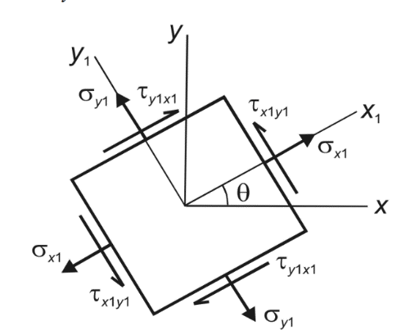

- =

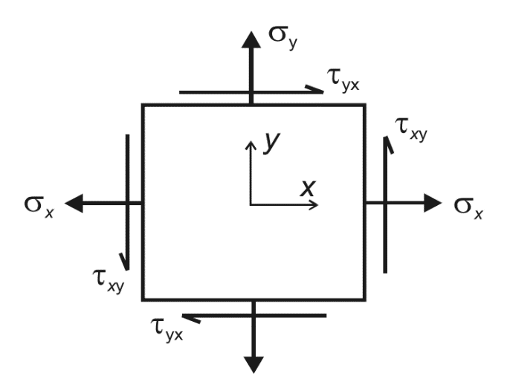

Mohr’s circle can be used, along with geometry and trigonometry, to derive equations to solve for angles and values of stresses at selected points. Either the double angle method or the pole method can be used for the analytical solutions.

It is important to note that general equations for solving stress transformation problems provided in reference books are based on knowing the state of stress on two planes that are perpendicular to each other. If the problem you are trying to solve does not meet this criterion, then none of the equations can be used.

However, the necessary equations can still be derived using geometry, trigonometry, and either the double angle method or the pole method. Either the double angle method or the pole method can be used to solve any problem.

The choice of which method to use should be based on which method can achieve the desired results with the least amount of effort for that problem.

## **Graphical Solution:**

C= avg =

R= $\sqrt{{\left(\frac{σ_{x}-σ_{y}}{2}\right)}^{2}+τ_{xy}^{2}}$

$$σ_{p1,p2}=c±R$$

$$τ_{max}=R$$

Variations of Normal stress and Shear stress value concerning angle Θ represent a form of a circle, which is known as Mohr’s Circle.

Mohr’s circle is the circle in which each point represents a plane in a stressed body in which the x-coordinate of the point represents the Normal stress, and the y-coordinate represents the Shear stress acting on the plane.

Mohr’s Circle diagram can be used for creating various questions in the GATE question paper, and the use of this has been seen over the years.

# Problem statement:

**EX:** Draw the Mohr’s Circle of the stress element shown below. Determine the principal stresses and the maximum shear stresses.

= -80 MPa

= +50 MPa

$τ_{xy}$ = 25 MPa

Coordinates of Points:

A: (-80,25) B: (50, -25)

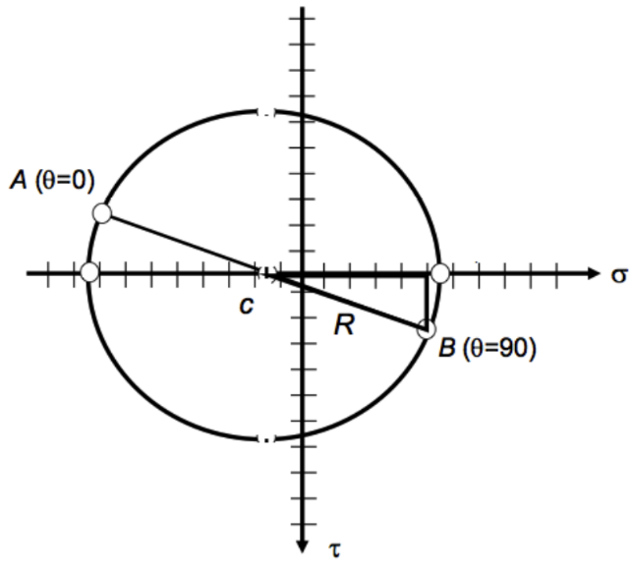Sol

C= avg = = = -15

R= = =69.6

= 54.6 MPa , $σ_{p2}$ = -84.6 MPa

$$τ_{max}=R= 69.6 MPA$$

# Solving the same problem using our project (GUI):

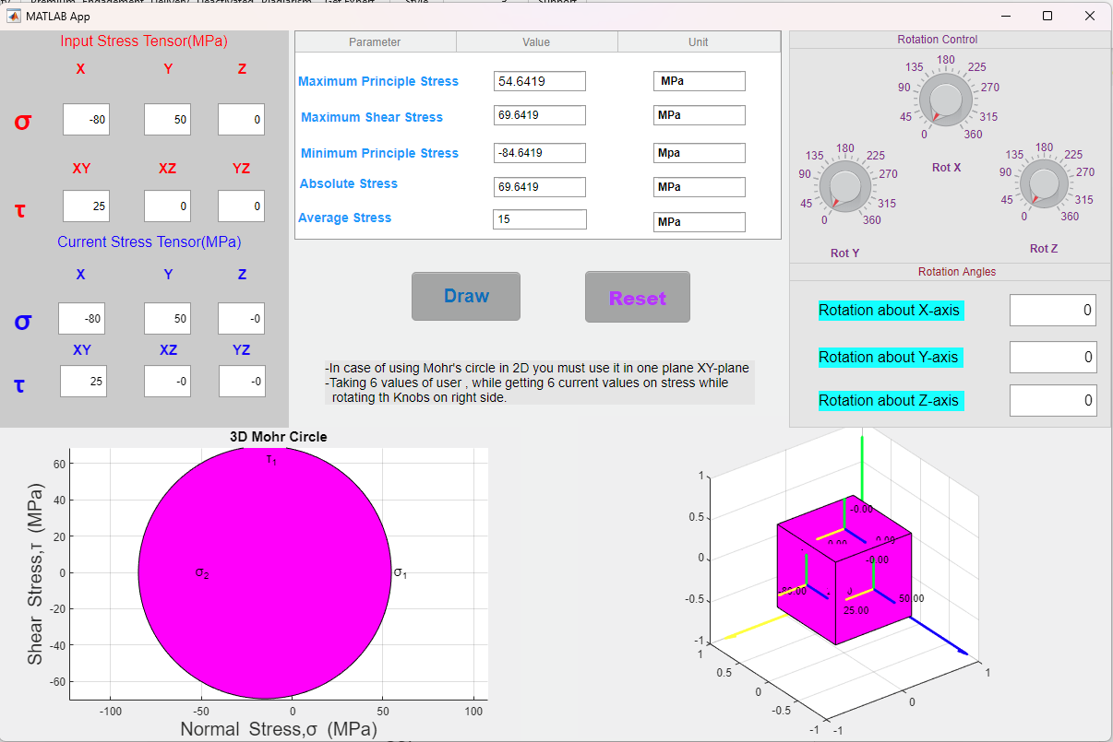

# Flow Chart:

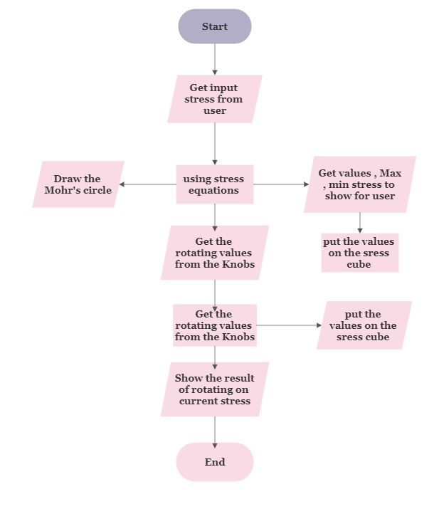

# Code:

Our code can be divided into main Function

First function we use is “Rotate “

This function is used for rotating element in 3D in three angles, we use it for rotating the stress Cube.

function rotation = rotate(app,matrix,rotx,roty,rotz)

%%about x-axis

w=[1 0 0 0;

0 cosd(rotx) -sind(rotx) 0;

0 sind(rotx) cosd(rotx) 0;

0 0 0 1];

%%about y-axis

r=[cosd(roty) , 0, sind(roty) 0;

0 1 , 0 0;

-sind(roty) 0 cosd(roty) 0;

0 0 0 1];

%%about z-axis

t=[cosd(rotz) -sind(rotz) 0 0;

sind(rotz) cosd(rotz) 0 0;

0 0 1 0;

0 0 0 1];

rotation =w*r*t*matrix;

end

second Function is “cube_3D”

this function is used for drawing a the stress cube and rotating it in the 3D while rotating vectors and variables of current stress in 3D too.

function cube_3D(app,rotx,roty,rotz)

cla(app.UIAxes,'reset');

sigma_x = -(app.EditField_8.Value);

sigma_y = -(app.EditField_9.Value);

sigma_z = -(app.EditField_13.Value);

tau_xy = -(app.EditField_10.Value);

tau_yz = -(app.EditField_11.Value);

tau_zx = -(app.EditField_12.Value);

sigma_x_dash=-((sigma_x+sigma_y)/2 + ((sigma_x-sigma_y)/2)*cos(2*rotx)+tau_xy*sin(2*rotx));

sigma_y_dash=-((sigma_y+sigma_z)/2 + ((sigma_y-sigma_z)/2)*cos(2*roty)+tau_yz*sin(2*roty));

sigma_z_dash=-((sigma_z+sigma_x)/2 + ((sigma_z-sigma_x)/2)*cos(2*rotz)+tau_zx*sin(2*rotz));

tau_xy_dash=-((-(sigma_x-sigma_y)/2)*sin(2*rotx)+tau_xy*cos(2*rotx));

tau_yz_dash=-((-(sigma_y-sigma_z)/2)*sin(2*roty)+tau_yz*cos(2*roty));

tau_zx_dash=-((-(sigma_z-sigma_x)/2)*sin(2*rotz)+tau_zx*cos(2*rotz));

tau_yx_dash=tau_xy_dash;

tau_zy_dash=tau_yz_dash;

tau_xz_dash=tau_zx_dash;

view(app.UIAxes,3);

c=[-.5 -.5 -.5 ;

-.5 .5 -.5 ;

.5 .5 -.5 ;

.5 -.5 -.5 ;

-.5 -.5 .5 ;

-.5 .5 .5 ;

.5 .5 .5 ;

.5 -.5 .5 ];

c=c';

a=[c; ones(1,8)];

faces = [1 2 3 4; 2 6 7 3; 4 3 7 8; 1 5 8 4; 1 2 6 5; 5 6 7 8];

r=[0 0 0 0 0 -0.4;

0 0 0 -0.4 0 0 ;

0.5 0.4 0.5 0 0.5 0 ];

mt1=[r; 1 1 1 1 1 1];

rt1 = rotate(app,mt1,rotx,roty,rotz);

q=[ 0 0 0 0 0 -0.4;

-0.5 -0.4 -0.5 0 -0.5 0 ;

0 0 0 0.4 0 0 ];

mt2=[q ; 1 1 1 1 1 1];

rt2 = rotate(app,mt2,rotx,roty,rotz);

k=[-0.5 -0.4 -0.5 0 -0.5 0 ;

0 0 0 0 0 -0.4;

0 0 0 0.4 0 0 ];

mt3=[k ; 1 1 1 1 1 1];

rt3 = rotate(app,mt3,rotx,roty,rotz);

axis(app.UIAxes, 'equal');

set(app.UIAxes, 'View', [45 45]);%axis equal and look good

quiver3(app.UIAxes,rt1(1,1),rt1(2,1),rt1(3,1),rt1(1,2),rt1(2,2),rt1(3,2),'linewidth',2,'color','g');

hold (app.UIAxes,"on");

quiver3(app.UIAxes,rt1(1,3),rt1(2,3),rt1(3,3),rt1(1,4),rt1(2,4),rt1(3,4),'linewidth',2,'color','b');

quiver3(app.UIAxes,rt1(1,5),rt1(2,5),rt1(3,5),rt1(1,6),rt1(2,6),rt1(3,6),'linewidth',2,'color','y');

quiver3(app.UIAxes,rt2(1,1),rt2(2,1),rt2(3,1),rt2(1,2),rt2(2,2),rt2(3,2),'linewidth',2,'color','b');

quiver3(app.UIAxes,rt2(1,3),rt2(2,3),rt2(3,3),rt2(1,4),rt2(2,4),rt2(3,4),'linewidth',2,'color','g');

quiver3(app.UIAxes,rt2(1,5),rt2(2,5),rt2(3,5),rt2(1,6),rt2(2,6),rt2(3,6),'linewidth',2,'color','y');

quiver3(app.UIAxes,rt3(1,1),rt3(2,1),rt3(3,1),rt3(1,2),rt3(2,2),rt3(3,2),'linewidth',2,'color','y');

quiver3(app.UIAxes,rt3(1,3),rt3(2,3),rt3(3,3),rt3(1,4),rt3(2,4),rt3(3,4),'linewidth',2,'color','g');

quiver3(app.UIAxes,rt3(1,5),rt3(2,5),rt3(3,5),rt3(1,6),rt3(2,6),rt3(3,6),'linewidth',2,'color','b');

quiver3(app.UIAxes,1,1,-1,-2,0,0,'linewidth',2,'color','y');

quiver3(app.UIAxes,1,1,-1,0,-2,0,'linewidth',2,'color','b');

quiver3(app.UIAxes,1,1,-1,0,0,2,'linewidth',2,'color','g');

%patch('Vertices',a,'Faces',faces,'FaceColor','r','facealpha',0.3);

h = rotate(app,a,rotx,roty,rotz);

h=h';

results=h(:,(1:3));

hold (app.UIAxes,"on");

patch(app.UIAxes,'Vertices',results,'Faces',faces,'FaceColor','m','facealpha',1);

p1=[-0.8 0.1 0;

0.1 -0.8 -0.1;

0 0 0.8];

p2=[p1;1 1 1];

p3=rotate(app,p2,rotx,roty,rotz);

text(app.UIAxes,p3(1,1),p3(2,1),p3(3,1),sprintf('%0.2f',sigma_x_dash),'color','k','fontsize',11);

text(app.UIAxes,p3(1,2),p3(2,2),p3(3,2),sprintf('%0.2f',sigma_y_dash),'color','k','fontsize',11);

text(app.UIAxes,p3(1,3),p3(2,3),p3(3,3),sprintf('%0.2f',sigma_z_dash),'color','k','fontsize',11);

p4=[-0.5 -0.1 -0.35;

-0.35 -0.5 -0.1;

0.1 0.4 0.5];

p5=[p4;1 1 1];

p6=rotate(app,p5,rotx,roty,rotz);

text(app.UIAxes,p6(1,1),p6(2,1),p6(3,1),sprintf('%0.2f',tau_xy_dash),'color','k','fontsize',11);

text(app.UIAxes,p6(1,2),p6(2,2),p6(3,2),sprintf('%0.2f',tau_yz_dash),'color','k','fontsize',11);

text(app.UIAxes,p6(1,3),p6(2,3),p6(3,3),sprintf('%0.2f',tau_zx_dash),'color','k','fontsize',11);

p7=[-0.4 0.1 -0.5;

-0.5 -0.35 0.1;

-0.1 0.5 0.4];

p8=[p7;1 1 1];

p9=rotate(app,p8,rotx,roty,rotz);

text(app.UIAxes,p9(1,1),p9(2,1),p9(3,1),sprintf('%0.2f',tau_yx_dash),'color','k','fontsize',11);

text(app.UIAxes,p9(1,2),p9(2,2),p9(3,2),sprintf('%0.2f',tau_zy_dash),'color','k','fontsize',11);

text(app.UIAxes,p9(1,3),p9(2,3),p9(3,3),sprintf('%0.2f',tau_xz_dash),'color','k','fontsize',11);

xlim(app.UIAxes,[-1 1]);

ylim(app.UIAxes,[-1 1]);

zlim(app.UIAxes,[-1 1]);

hold (app.UIAxes,"on");

grid (app.UIAxes,"on");

end

third function is “Tensor”

this function is used to show and solve the equation of current stress tensor , and applying them on field to show them while rotating the knobs

function Tensor(app,rotx,roty,rotz)

%get from user

sigma_x = -(app.EditField_8.Value);

sigma_y = -(app.EditField_9.Value);

sigma_z = -(app.EditField_13.Value);

tau_xy = -(app.EditField_10.Value);

tau_yz = -(app.EditField_11.Value);

tau_zx = -(app.EditField_12.Value);

%current tensor equation

sigma_x_dash=-((sigma_x+sigma_y)/2 + ((sigma_x-sigma_y)/2)*cos(2*rotx)+tau_xy*sin(2*rotx));

sigma_y_dash=-((sigma_y+sigma_z)/2 + ((sigma_y-sigma_z)/2)*cos(2*roty)+tau_yz*sin(2*roty));

sigma_z_dash=-((sigma_z+sigma_x)/2 + ((sigma_z-sigma_x)/2)*cos(2*rotz)+tau_zx*sin(2*rotz));

tau_xy_dash=-((-(sigma_x-sigma_y)/2)*sin(2*rotx)+tau_xy*cos(2*rotx));

tau_yz_dash=-((-(sigma_y-sigma_z)/2)*sin(2*roty)+tau_yz*cos(2*roty));

tau_zx_dash=-((-(sigma_z-sigma_x)/2)*sin(2*rotz)+tau_zx*cos(2*rotz));

tau_yx_dash=tau_xy_dash;

tau_zy_dash=tau_yz_dash;

tau_xz_dash=tau_zx_dash;

%show the results on field ...

app.EditField_14.Value=double(sigma_x_dash);

app.EditField_15.Value=double(sigma_y_dash);

app.EditField_16.Value=double(sigma_z_dash);

app.EditField_17.Value=double(tau_xy_dash);

app.EditField_18.Value=double(tau_yz_dash);

app.EditField_19.Value=double(tau_zx_dash);

end

Fourth function is “mohrs_3d_2d”

This function is used in calculating the values of maximum, minimum, average, absolute and drawing the Mohr’s circle in a 2D case and 3D case also with special condition of drawing 2D in XY-plan only.

function Mohr_3d_2d(app)

cla(app.UIAxes2, "reset");

%values from user...

sigma_x = -(app.EditField_8.Value);

sigma_y = -(app.EditField_9.Value);

sigma_z = -(app.EditField_13.Value);

tau_xy = -(app.EditField_10.Value);

tau_yz = -(app.EditField_11.Value);

tau_zx = -(app.EditField_12.Value);

tau_yx=tau_xy;

tau_zy=tau_yz;

tau_xz=tau_zx;

% Coefficients for Mohr's Ciecle

c3 = 1;

c2 = sigma_x+sigma_y+sigma_z;

c1 = sigma_x*sigma_y+sigma_y*sigma_z+sigma_z*sigma_x -tau_xy^2 -tau_yz^2 -tau_zx^2;

c0 = sigma_x*sigma_y*sigma_z + 2*tau_xy*tau_yz*tau_zx -(sigma_x*tau_yz^2+sigma_y*tau_zx^2+sigma_z*tau_xy^2);

% Principal stresses

normal_stresses = roots([c3 c2 c1 c0]);

A = sort(normal_stresses,'descend');

sigma_1 = A(1);

sigma_2 = A(2);

sigma_3 = A(3);

sigma = [sigma_1;sigma_2;sigma_3];

sigma_max = max(sigma);

sigma_min = min(sigma);

tau_1 = (sigma_1-sigma_3)/2;

tau_2 = (sigma_1-sigma_2)/2;

tau_3 = (sigma_2-sigma_3)/2;

tau = [tau_1;tau_2;tau_3];

tau_max = max(tau);

absolute_stress=abs((sigma_max-sigma_min)/2);

app.MaximumPrincipleStressEditField.Value= num2str(sigma_max);

app.MinimumPrincipleStressEditField.Value= num2str(sigma_min);

app.MaximumShearStressEditField.Value=num2str(tau_max);

app.AbsoluteStressEditField.Value=num2str(absolute_stress);

% Plotting

theta = 0:0.01:2*pi;

C1 = [(sigma_1+sigma_3)/2 0];

C2 = [(sigma_1+sigma_2)/2 0];

C3 = [(sigma_2+sigma_3)/2 0];

%cirlce1=[C1(1)+tau_1*cos(theta') C1(2)+tau_1*sin(theta')];

%cirlce2=[C2(1)+tau_2*cos(theta') C2(2)+tau_2*sin(theta')];

%cirlce3=[C3(1)+tau_3*cos(theta') C3(2)+tau_3*sin(theta')];

%% for the 2d condiong

if sigma_z==0 && tau_yz==0 && tau_xz==0

% sigma_max_2D=(sigma_x+sigma_y)/2+(((sigma_x-sigma_y)/2)^(2) + (tau_xy)^(2))^(1/2)

% sigma_max_2D = max(sigma_max_2D);

% sigma_min_2D = min(MAt_MAX_MIN_2D);

% app.MaximumPrincipleStressEditField.Value= num2str(sigma_max_2D);

% app.MinimumPrincipleStressEditField.Value= num2str(sigma_min_2D);

% Cemter_2d=(sigma_x+sigma_y)/2;

% raduis_2d=(((sigma_x+sigma_y)/2)^(2)+(tau_xy)^(2))^(1/2);

% sigma_max_2D = Cemter_2d+raduis_2d;

% sigma_min_2D = Cemter_2d-raduis_2d;

%plotting

plot(app.UIAxes2,C1(1)+tau_1*cos(theta),C1(2)+tau_1*sin(theta),'m');

axis(app.UIAxes2,"equal")

grid (app.UIAxes2,"on")

fill(app.UIAxes2,C1(1)+tau_1*cos(theta),C1(2)+tau_1*sin(theta),"m");

%labels

if sigma_1>0

text(app.UIAxes2,sigma_1*1.01,0,'\sigma_1','fontsize',15);

else

text(app.UIAxes2,sigma_1*0.95,0,'\sigma_1','fontsize',15);

end

if sigma_2>0

text(app.UIAxes2,-sigma_1*1.0,0,'\sigma_2','fontsize',15);

else

text(app.UIAxes2,-sigma_1*0.99,0,'\sigma_2','fontsize',15);

end

text(app.UIAxes2,C1(1),tau_1*0.9,'\tau_1','fontsize',15);

%average for the 2d

average_stress_2D=(sigma_x+sigma_y)/2;

app.AverageStressEditField.Value=num2str(average_stress_2D);

%for the 3d condisions the rest of them

elseif (sigma_x~=0 && sigma_y~=0 && sigma_z~=0) && (tau_xy~=0 || tau_yz~=0 || tau_xz~=0)

sigma_1 = A(1);

sigma_2 = A(2);

sigma_3 = A(3);

sigma = [sigma_1;sigma_2;sigma_3];

sigma_max = max(sigma);

sigma_min = min(sigma);

app.MaximumPrincipleStressEditField.Value= num2str(sigma_max);

app.MinimumPrincipleStressEditField.Value= num2str(sigma_min);

%plotting

plot(app.UIAxes2,C1(1)+tau_1*cos(theta),C1(2)+tau_1*sin(theta),'m');

hold (app.UIAxes2,"on")

plot(app.UIAxes2,C2(1)+tau_2*cos(theta),C2(2)+tau_2*sin(theta),'g');

hold (app.UIAxes2,"on")

plot(app.UIAxes2,C3(1)+tau_3*cos(theta),C3(2)+tau_3*sin(theta),'r');

hold (app.UIAxes2,"on")

axis(app.UIAxes2,"equal")

grid (app.UIAxes2,"on")

%labels

if sigma_1>0

text(app.UIAxes2,sigma_1*1.01,0,'\sigma_1','fontsize',15);

else

text(app.UIAxes2,sigma_1*0.95,0,'\sigma_1','fontsize',15);

end

if sigma_2>0

text(app.UIAxes2,sigma_2*1.0,0,'\sigma_2','fontsize',15);

else

text(app.UIAxes2,sigma_2*0.99,0,'\sigma_2','fontsize',15);

end

if sigma_3>0

text(app.UIAxes2,sigma_3*1.1,0,'\sigma_3','fontsize',15);

else

text(app.UIAxes2,sigma_3*0.99,0,'\sigma_3','fontsize',15);

end

text(app.UIAxes2,C1(1),tau_1*0.9,'\tau_1','fontsize',15);

text(app.UIAxes2,C2(1),tau_2*0.9,'\tau_2','fontsize',15);

text(app.UIAxes2,C3(1),tau_3*0.9,'\tau_3','fontsize',15);

%avergae for the 3d

average_stress_3D=(sigma_x+sigma_y+sigma_z)/3;

app.AverageStressEditField.Value=num2str(average_stress_3D);

elseif (tau_xy~=0 && tau_yz~=0 && tau_xz~=0) && (sigma_x~=0 || sigma_y~=0 || sigma_z~=0)

sigma_1 = A(1);

sigma_2 = A(2);

sigma_3 = A(3);

sigma = [sigma_1;sigma_2;sigma_3];

sigma_max = max(sigma);

sigma_min = min(sigma);

app.MaximumPrincipleStressEditField.Value= num2str(sigma_max);

app.MinimumPrincipleStressEditField.Value= num2str(sigma_min);

%plotting

plot(app.UIAxes2,C1(1)+tau_1*cos(theta),C1(2)+tau_1*sin(theta),'m');

hold (app.UIAxes2,"on")

plot(app.UIAxes2,C2(1)+tau_2*cos(theta),C2(2)+tau_2*sin(theta),'g');

hold (app.UIAxes2,"on")

plot(app.UIAxes2,C3(1)+tau_3*cos(theta),C3(2)+tau_3*sin(theta),'r');

hold (app.UIAxes2,"on")

axis(app.UIAxes2,"equal")

grid (app.UIAxes2,"on")

%labels

if sigma_1>0

text(app.UIAxes2,sigma_1*1.01,0,'\sigma_1','fontsize',15);

else

text(app.UIAxes2,sigma_1*0.95,0,'\sigma_1','fontsize',15);

end

if sigma_2>0

text(app.UIAxes2,sigma_2*1.0,0,'\sigma_2','fontsize',15);

else

text(app.UIAxes2,sigma_2*0.99,0,'\sigma_2','fontsize',15);

end

if sigma_3>0

text(app.UIAxes2,sigma_3*1.1,0,'\sigma_3','fontsize',15);

else

text(app.UIAxes2,sigma_3*0.99,0,'\sigma_3','fontsize',15);

end

text(app.UIAxes2,C1(1),tau_1*0.9,'\tau_1','fontsize',15);

text(app.UIAxes2,C2(1),tau_2*0.9,'\tau_2','fontsize',15);

text(app.UIAxes2,C3(1),tau_3*0.9,'\tau_3','fontsize',15);

%avergae for the 3d

average_stress_3D=(sigma_x+sigma_y+sigma_z)/3;

app.AverageStressEditField.Value=num2str(average_stress_3D);

else

sigma_1 = A(1);

sigma_2 = A(2);

sigma_3 = A(3);

sigma = [sigma_1;sigma_2;sigma_3];

sigma_max = max(sigma);

sigma_min = min(sigma);

app.MaximumPrincipleStressEditField.Value= num2str(sigma_max);

app.MinimumPrincipleStressEditField.Value= num2str(sigma_min);

%plotting

plot(app.UIAxes2,C1(1)+tau_1*cos(theta),C1(2)+tau_1*sin(theta),'m');

hold (app.UIAxes2,"on")

plot(app.UIAxes2,C2(1)+tau_2*cos(theta),C2(2)+tau_2*sin(theta),'g');

hold (app.UIAxes2,"on")

plot(app.UIAxes2,C3(1)+tau_3*cos(theta),C3(2)+tau_3*sin(theta),'r');

hold (app.UIAxes2,"on")

axis(app.UIAxes2,"equal")

grid (app.UIAxes2,"on")

%labels

if sigma_1>0

text(app.UIAxes2,sigma_1*1.01,0,'\sigma_1','fontsize',15);

else

text(app.UIAxes2,sigma_1*0.95,0,'\sigma_1','fontsize',15);

end

if sigma_2>0

text(app.UIAxes2,sigma_2*1.0,0,'\sigma_2','fontsize',15);

else

text(app.UIAxes2,sigma_2*0.99,0,'\sigma_2','fontsize',15);

end

if sigma_3>0

text(app.UIAxes2,sigma_3*1.1,0,'\sigma_3','fontsize',15);

else

text(app.UIAxes2,sigma_3*0.99,0,'\sigma_3','fontsize',15);

end

text(app.UIAxes2,C1(1),tau_1*0.9,'\tau_1','fontsize',15);

text(app.UIAxes2,C2(1),tau_2*0.9,'\tau_2','fontsize',15);

text(app.UIAxes2,C3(1),tau_3*0.9,'\tau_3','fontsize',15);

%avergae for the 3d

average_stress_3D=(sigma_x+sigma_y+sigma_z)/3;

app.AverageStressEditField.Value=num2str(average_stress_3D);

end

xlabel(app.UIAxes2,'Normal Stress,\sigma (MPa)','fontsize',15);

ylabel(app.UIAxes2,'Shear Stress,\tau (MPa)','fontsize',15);

title(app.UIAxes2,'3D Mohr Circle','fontsize',15);

end

the fifth function is “Restart”

this function is used to restart all the program to reinput the values and draw again and get outputs.

function restart(app)

cla(app.UIAxes,'reset');

cla(app.UIAxes2,'reset');

Tensor(app,0,0,0);

%restrt zero values in all fields

app.MaximumPrincipleStressEditField.Value= num2str(0);

app.MinimumPrincipleStressEditField.Value= num2str(0);

app.MaximumShearStressEditField.Value=num2str(0);

app.AbsoluteStressEditField.Value=num2str(0);

app.AverageStressEditField.Value=num2str(0);

app.EditField_8.Value=0;

app.EditField_9.Value=0;

app.EditField_13.Value=0;

app.EditField_10.Value=0;

app.EditField_11.Value=0;

app.EditField_12.Value=0;

app.EditField_14.Value=double(0);

app.EditField_15.Value=double(0);

app.EditField_16.Value=double(0);

app.EditField_17.Value=double(0);

app.EditField_18.Value=double(0);

app.EditField_19.Value=double(0);

app.EditField_23.Value=0;

app.EditField_24.Value=0;

app.EditField_22.Value=0;

app.RotZKnob.Value=0;

app.RotYKnob.Value=0;

app.RotXKnob.Value=0;

end

the whole code is written by us only, no use of out functions, by the use of Doctor and teacher assistant

and with help of another teacher assistant in production department to finish this project.

# Conclusion:

The conclusion of this project can be that mohr’s circle is a good way to get easy outputs for stress analysis, and hard to be in the real world because it takes much time to be drawn and getting values, but with coding we can get it with just klick on a button. So we finish this report with best wish to use our project.

# Refrences:

* Mechanics of Materials for Dummies by James H. Allen III
* Metal forming third Edition Mechanics and Metallurgy
* <https://pantelisliolios.com/mohr-circle-3d/>
* <https://byjusexamprep.com/mohrs-circle-i>
* <https://www.roymech.co.uk/Useful_Tables/Mechanics/Mohrs_circle.html>